5.1 New study Technology Innovation

**SuccessFactor OData APIs(V2) Access From POSTMAN**

The Open Data Protocol (OData) is a standardized protocol for creating and consuming data APIs.OData builds on core protocols like HTTP, and commonly accepted methodologies like REST. The result is a uniform way to expose full-featured data APIs. OData provides both a standard for how to represent your data and a metadata method to describe the structure of your data, and the operations available in your API. This document focuses on OData version 2.0. [Details](https://help.sap.com/docs/SAP_SUCCESSFACTORS_PLATFORM/d599f15995d348a1b45ba5603e2aba9b/03e1fc3791684367a6a76a614a2916de.html)

# **SAP SuccessFactors API Servers :**

| **Data Center** | **Environment** | **Location** | **API Server** |
| --- | --- | --- | --- |
| DC44 | Preview | Singapore | https://api44preview.sapsf.com/ |
| DC44 | Production | Singapore | https://api44.sapsf.com/ |

**Step 1:** First You need to authenticate with Basic Authentication. So You need to enter

Username = [userName@companyID], Password: [yourPassword] on Basic Auth Type.

**Example** : 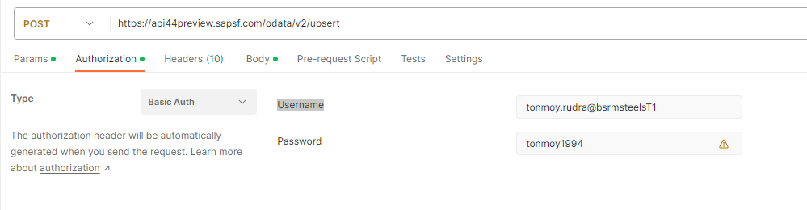

**Step 2:** Now I want to get email address for a user. So how can I do this?

HTTP Method: GET

URL: https://api44preview.sapsf.com/odata/v2/PerEmail?$filter=emailType eq

'22151' and personIdExternal eq '100628' and isPrimary eq 'true'&$select=emailAddress&$format=JSON

Response:

{

    "d": {

        "results": [

            {

                "__metadata": {

                    "uri": "https://api44preview.sapsf.com/odata/v2/PerEmail(emailType='22151',personIdExternal='100628')",

                    "type": "SFOData.PerEmail"

                },

                "emailAddress": "saiful.haque@bsrm.com"

            }

        ]

    }

}

Example: 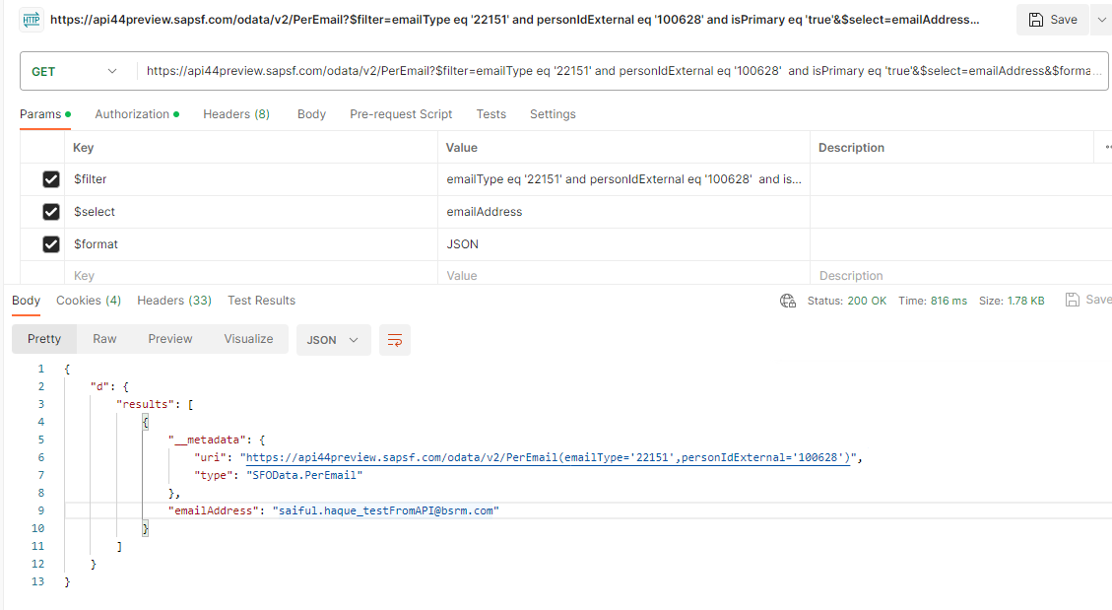

**Step 3:** Now I update email address for this user.

Method: POST

URL: <https://api44preview.sapsf.com/odata/v2/upsert>

Req BODY: {

    "__metadata": {

        "uri": "PerEmail(emailType='22151',personIdExternal='100628')",

        "type": "SFOData.PerEmail"

    },

    "emailAddress": "saiful.haque_testFromAPI@bsrm.com"

}

Example: 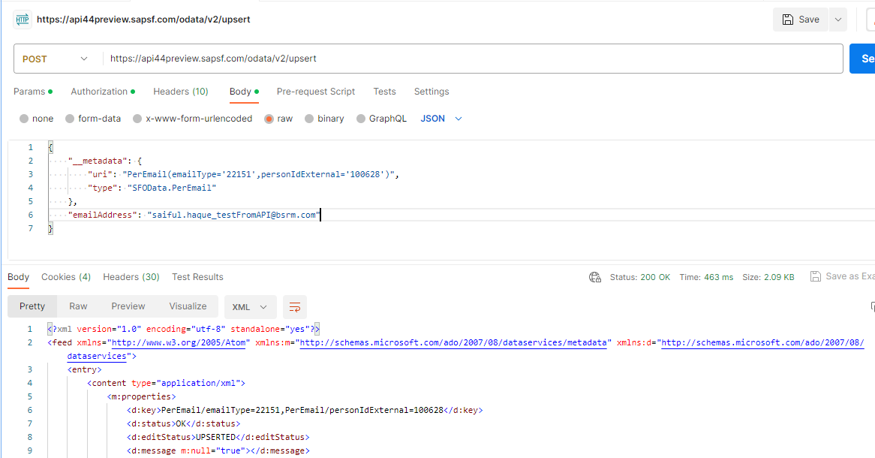

And email is updated. 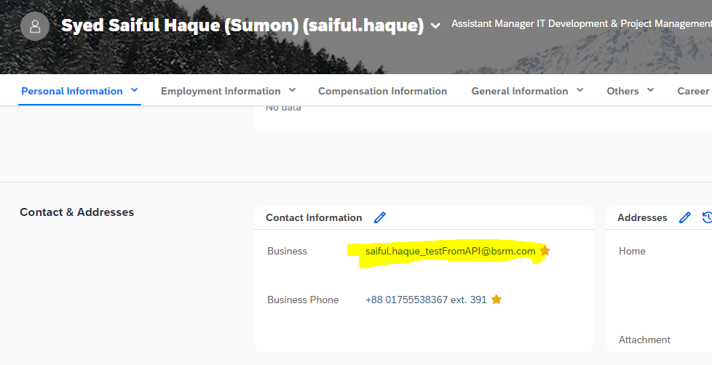

Ref Documentation: <https://help.sap.com/docs/SAP_SUCCESSFACTORS_PLATFORM/d599f15995d348a1b45ba5603e2aba9b/03e1fc3791684367a6a76a614a2916de.html>